***QUSETION 1:***

**#include<stdio.h>**

**int main()**

**{**

**int n,r;**

**int bin=0,pos=1;**

**printf("Enter a number ");**

**scanf("%d",&n);**

**if (n==0)**

**{**

**printf("0\n");**

**return 0;**

**}**

**while(n>0)**

**{**

**r=n%2;**

**bin=bin+(r*pos);**

**n=n/2;**

**pos=pos*10;**

**}**

**printf("Binary Number : %d",bin);**

**return 0;**

**}**

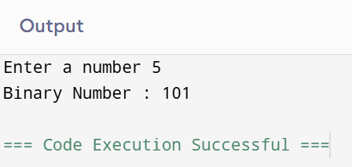

***QUESTION 2:***

**#include<stdio.h>**

**#include<string.h>**

**#include<ctype.h>**

**int main()**

**{**

**char str[100];**

**char *ptr;**

**int vowels=0,consonants=0;**

**printf("Enter a string ");**

**fgets(str,sizeof(str),stdin);**

**ptr=str;**

**while(*ptr!='\0')**

**{**

**char ch=tolower(*ptr);**

**if(ch=='a'||ch=='e'||ch=='i'||ch=='o'||ch=='u')**

**{**

**vowels++;**

**}**

**else if(ch>='a'&&ch<='z')**

**{**

**consonants++;**

**}**

**ptr++;**

**}**

**printf("Number of vowels = %d\n",vowels);**

**printf("Number of consonants = %d",consonants);**

**return 0;**

**}**

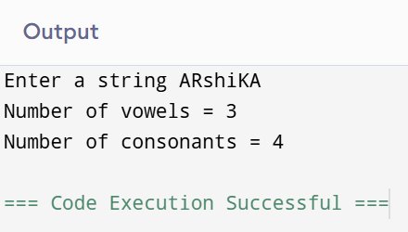

***QUESTION 3:***

**#include<stdio.h>**

**int add(float a,float b)**

**{**

**return (a+b);**

**}**

**int subtract(float a,float b)**

**{**

**return (a-b);**

**}**

**int multiply(float a,float b)**

**{**

**return (a*b);**

**}**

**float divide(float a,float b)**

**{**

**return (a/b);**

**}**

**int main()**

**{**

**int choice;**

**float num1, num2, result;**

**printf("1 for Addition\n");**

**printf("2 for Subtraction\n");**

**printf("3 for Multiplication\n");**

**printf("4 for Division\n");**

**scanf("%d",&choice);**

**printf("Enter two numbers ");**

**scanf("%f %f",&num1,&num2);**

**switch (choice)**

**{**

**case 1:**

**result=add(num1,num2);**

**printf("Result = %.2f",result);**

**break;**

**case 2:**

**result=subtract(num1,num2);**

**printf("Result = %.2f",result);**

**break;**

**case 3:**

**result = multiply(num1,num2);**

**printf("Result = %.2f",result);**

**break;**

**case 4:**

**result=divide(num1,num2);**

**printf("Result = %.2f", result);**

**break;**

**default:**

**printf("Invalid choice");**

**}**

**return 0;**

**}**

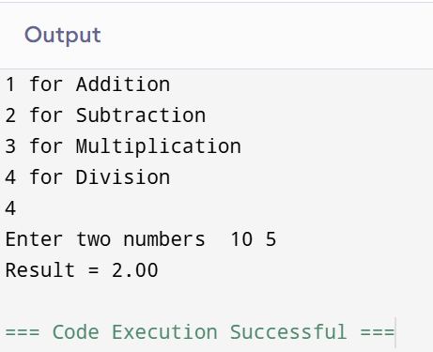

***QUESTION 4:***

**#include<stdio.h>**

**int main()**

**{**

**int n;**

**printf("Enter the value of n: ");**

**scanf("%d",&n);**

**for(int i=1;i<=n;i++)**

**{**

**for(int j=1;j<=n-i;j++)**

**{**

**printf(" ");**

**}**

**for (int j=1;j<=2*i-1;j++)**

**{**

**printf("*");**

**}**

**printf("\n");**

**}**

**for(int i=n-1;i>=1;i--)**

**{**

**for(int j=1;j<=n-i;j++)**

**{**

**printf(" ");**

**}**

**for(int j=1;j<=2*i-1;j++)**

**{**

**printf("*");**

**}**

**printf("\n");**

**}**

**return 0;**

**}**

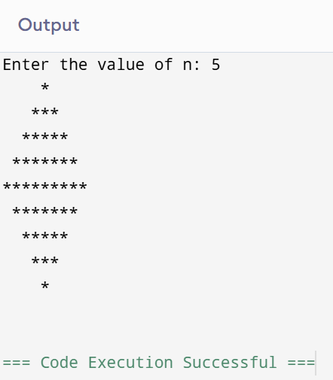

***QUESTION 5:***

**#include<stdio.h>**

**#include<string.h>**

**int main()**

**{**

**char str[]="Hello";**

**char *ptr=str;**

**int length=0;**

**while(*ptr!='\0')**

**{**

**length++;**

**ptr++;**

**}**

**printf("Length of the string = %d",length);**

**return 0;**

**}**

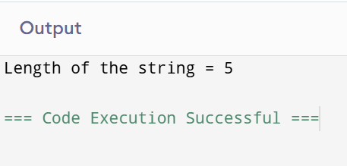

***QUESTION 6:***

**#include <stdio.h>**

**int gcd(int a,int b)**

**{**

**if (b==0)**

**{**

**return a;**

**}**

**else**

**{**

**return gcd(b,a%b);**

**}**

**}**

**int main()**

**{**

**int n1,n2;**

**printf("Enter two numbers: ");**

**scanf("%d %d",&n1,&n2);**

**printf("GCD is %d ",gcd(n1,n2));**

**return 0;**

**}**



